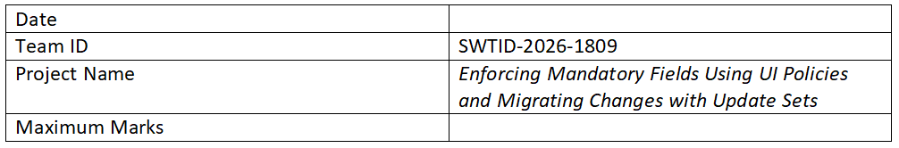

Problem – Solution Fit Template
Project Title: Implementing Mandatory Field Validation Using UI Policies and Migrating Changes Through Update Sets

Problem – Solution Fit
The problem-solution fit ensures that the identified issue is effectively addressed by the proposed solution. In this project, incomplete data entry and improper change management are common problems in systems.

Purpose
• Ensure accurate data entry by enforcing mandatory fields using UI Policies.
• Improve system reliability by properly managing and migrating changes using Update Sets.
• Reduce manual errors and increase efficiency in workflows.
• Enhance user experience by guiding users to complete required fields.
• Maintain consistency across different system environments.

Problem
Users often skip important fields while submitting forms, leading to incomplete and unreliable data. Additionally, system changes are sometimes not tracked or migrated properly, causing inconsistencies.

Solution
UI Policies are used to dynamically enforce mandatory fields based on conditions, ensuring all required data is entered. Update Sets are used to capture, track, and migrate system changes efficiently across environments.

Expected Outcome
• Improved data accuracy
• Reduced errors in form submission
• Efficient change management
• Better system reliability and consistency

